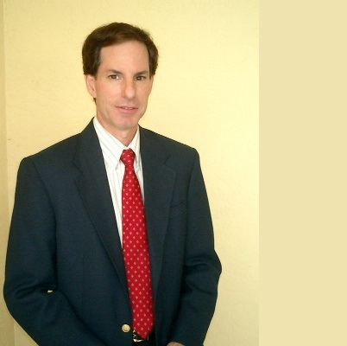
Book The Best Friend of Small Business!

JOHN LAROSA
President, Marketdata LLC

"My passion is to turn dreamers into entrepreneurs."

HIGHLIGHT VIDEO:
www.marketdataenterprises.com/speaker

BOOKING INFO:
813-971-8080
john@marketdataenterprises.com

Marketdata LLC
7210 Wareham Drive
Tampa, FL 33647
www.marketdataenterprises.com

He also likes to protect consumers. His latest book: Scam Nation: Fighting America’s $257 Billion Epidemic of Consumer Frauds & Cons

If your audience wants new insights, new ideas and a big dose of creativity, no one has more passion than business expert John LaRosa, President of Marketdata LLC, a 39-year old independent market research publishing and consulting firm. He’s a speaker, coach, consultant, and blogger. Yes, he’s an author—not of one book, but 300+ major industry market research studies, covering dozens of service and healthcare sectors.

By virtue of his extensive knowledge of diverse markets and industries, coupled with his experience working for Fortune 500 companies, a trade association, manufacturers, small business, and self-employment, John possesses a rare combination of business experience.

Sample Speaking Topics:

- Entrepreneurship Can Set You Free
- Innovation for Small Business Success
- Industry Leadership via Innovation
- Protection From The Scam Economy
- Why Market Research is Important
- Is Your Business Customer-Friendly?
- Keys To Success in The Weight Loss Market

Nationally Recognized:

John LaRosa’s / Marketdata’s market research has been quoted since 1989 by the… Wall Street Journal, N.Y. Times, Newsweek, USA Today, Forbes, Fortune, Business Week, Entrepreneur, Nutrition Business Journal, LA Times, Boston Globe, Chicago Sun Times, dozens of trade groups, and hundreds of local newspapers nationwide. Mr. LaRosa has appeared on CNN, Nightline, ABC, FOX-TV and other stations, and is regularly interviewed by the media.

